Target Audiences & Age Ratings in Games Design
Purpose of This Worksheet
This worksheet explores:
- How target audiences are identified in games design
- How the PEGI rating system works
- How games are designed to meet age ratings
- Why target audiences are more complex than just age
You will research, analyse, and explain your ideas using images, examples, and your own interpretation.

What Is a Target Audience?
Task:
In your own words, explain:
- What does target audience mean in games design?
- Why is it important for game developers to know their target audience?
- What factors (other than age) might affect a target audience?
Examples to consider:
- Interests
- Skill level
- Preferred genres
- Platform (PC, console, mobile)
- Play style (casual, competitive, story-focused)
In the context of games development, the target audience is referring to the group of people / demographic that we are trying to reach with our game’s design, story and gameplay. It is important for game developers to know their target audience as this will guide how they design their game and mechanics. For example, if my target audience was young people who like cars, I would design a high energy racing game. However, if my target audience was older people who enjoy kindle games, I would design a calming puzzle game.

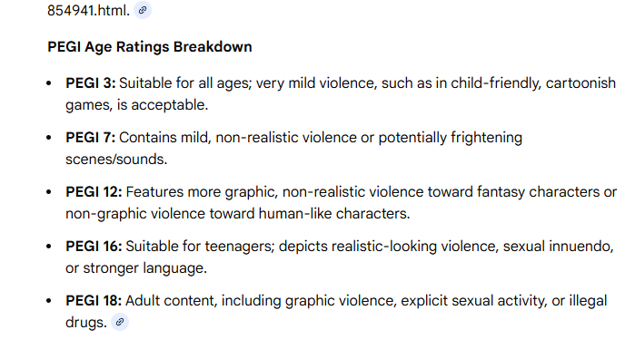

Exploring the PEGI Rating System
Task:
Visit the PEGI rating website and explore the different ratings and content descriptors. Use this to fill the graphs below:
PEGI 3

PEGI Description:
The content of games with a PEGI 3 rating is considered suitable for all age groups. The game should not contain any sounds or pictures that are likely to frighten young children. A very mild form of violence (in a comical context or a childlike setting) is acceptable. No bad language should be heard.
My Interpretation:
A game that is family friendly, appropriate for all audiences. This may be a children’s film or series like Thomas the tank engine.

PEGI 7

PEGI Description:
Game content with scenes or sounds that can possibly be frightening to younger children should fall in this category. Very mild forms of violence (implied, non-detailed, or non-realistic violence) are acceptable for a game with a PEGI 7 rating.
My Interpretation:
A game that, whilst kid friendly, may contain minor forms of violence. An example would be peter pan as whilst this is a kid’s film, it still contains a non-detailed form of violence like swordplay.

PEGI 12

PEGI Description:
Video games that show violence of a slightly more graphic nature towards fantasy characters or non-realistic violence towards human-like characters would fall in this age category. Sexual innuendo or sexual posturing can be present, while any bad language in this category must be mild.
My Interpretation:
A game that may contain non-realistic violence towards humans and realistic violence towards fantasy characters. Cursing should also be mild. An example would be street fighter, whilst it is a primarily violent game, the violence is non-realistic.

PEGI 16

PEGI Description:
This rating is applied once the depiction of violence (or sexual activity) reaches a stage that looks the same as would be expected in real life. The use of bad language in games with a PEGI 16 rating can be more extreme, while the use of tobacco, alcohol or illegal drugs can also be present.
My Interpretation:
A game that contains a realistic level of violence and or sexual activity. More extreme cursing can be present alongside tobacco, alcohol and drugs. An example would be boxing games that contain realistic and life-like combat and graphics.

PEGI 18

PEGI Description:
The adult classification is applied when the level of violence reaches a stage where it becomes a depiction of gross violence, apparently motiveless killing, or violence towards defenceless characters. The glamorisation of the use of illegal drugs and of the simulation of gambling, and explicit sexual activity should also fall into this age category.
My Interpretation:
A game that may contain high-level violence and gore, use of illegal drugs, realistic gambling and explicit sexual activity. An example of an PEGI 18 game would be DOOM, containing high levels of gross violence and gore.

PEGI Content Descriptors
Choose at least three PEGI content descriptors (e.g. violence, fear, gambling, bad language).
For each one:
- Insert the icon
- Explain what it means
- Give an example of how it might appear in a game
Icon | Explanation | Example
 | The game contains depictions of violence. In games rated PEGI 7 this can only be non-realistic or non-detailed violence. Games rated PEGI 12 can include violence in a fantasy environment or non-realistic violence towards human-like characters, whereas games rated PEGI 16 or 18 have increasingly more realistic-looking violence.​ | May appear in game where characters or the player take part in violent combat and or murder.
 | This content descriptor can accompany a PEGI 12 rating if the game includes sexual posturing or innuendo, a PEGI 16 rating if there is erotic nudity or sexual intercourse without visible genitals or a PEGI 18 rating if there is explicit sexual activity in the game. Depictions of nudity in a non-sexual context do not require a specific age rating, and this descriptor would not be necessary. | May appear in game as a scene of two characters having sex or in explicit positions.
 | The game offers players the option to purchase digital goods or services with real-world currency. Such purchases include additional content (bonus levels, outfits, surprise items, music), but also upgrades (e.g. to disable ads), subscriptions to updates, virtual coins and other forms of in-game currency. | May appear in game as a currency that the player can purchase with real money or loot boxes that can be purchased.

PEGI in Practice – Example Game
Task:
Choose ONE game and analyse how it fits its PEGI rating.
Game Title: Brawlhalla
PEGI Rating: 7
Developer / Publisher: Blue Mammoth Games, Ubisoft
Analysis:
- Why do you think this game received this PEGI rating?
- What content supports this rating? Violence? Language? Themes? Fear or horror?
This game is a platformer fighting game and contains only mild forms of violence. However, this game does also contain in-game purchases, chance based in-game purchases, online interactivity and in-game chat.

Design Choices:
- How does the game manage or limit content to stay within its PEGI rating?
- Are there things the developers avoid including?
The creators of Brawlhalla limit the realism in their violent content to stay within the game’s PEGI rating.

Insert screenshots or promotional images (credited under those images)
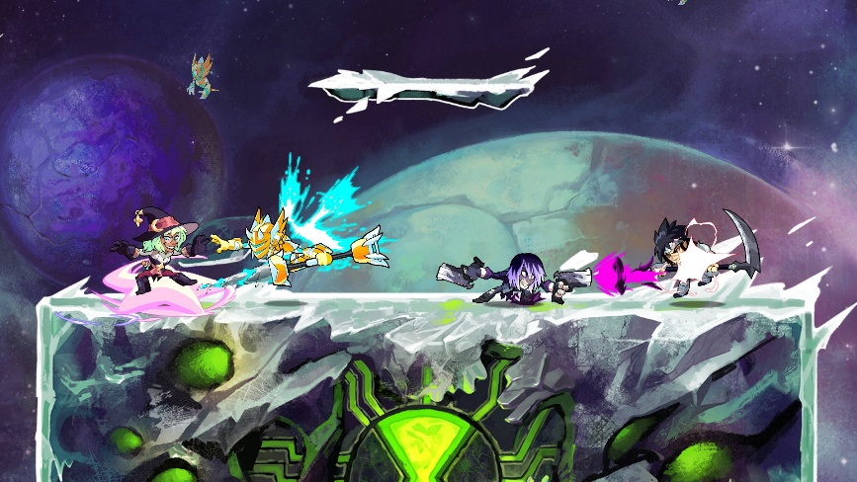
Screenshot from steam store page. https://store.steampowered.com/app/291550/Brawlhalla/

Target Audiences Beyond Age Ratings
Community Tags, Demographics & Player Identity
Age ratings like PEGI describe what content is allowed, but they do not describe who actually plays the game. Many developers and platforms use player behaviour, interests, and demographics to understand their audience.
This section explores how Steam’s community tagging system helps define real target audiences.

Exploring Steam’s Community Tagging System
Steam allows players to tag games using keywords that describe:
- Gameplay style
- Mood
- Difficulty
- Theme
- Player experience
These tags help games reach the right audience, not just the right age.
Task:
Visit the Steam store and choose ONE game.
Game Title: Terraria
Developer / Publisher: Re-Logic
Insert a screenshot of the game’s Steam tags
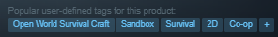

Tag Analysis
List 5–8 tags used for this game.
Game tag | What it means (be descriptive and give examples)
Open World Survival Craft | This game is set in an explorable environment where players start with minimal resources and can explore to gather materials and build shelters.
Sandbox | In this game, the player can use in-game resources to build whatever they want, whether it be a house or a boss arena.
Survival | In this game the player must survive against enemies, bosses and random events.
2D | This game is Two Dimensional and has a pixel-art style.
Co-Op | Game can be played with multiple people like friends or family.

Demographics & Player Profiles
Task:
Based on the Steam tags and the game you chose, describe the likely target audience.
Target Audience Profile:
- Age range (approximate)
- Skill level (casual, experienced, competitive)
- Interests (e.g. strategy, horror, fast action, story)
- Play style (solo, co-op, competitive, relaxed)
- Platform preferences
The target audience for this game would likely be someone in the age range of 12 and up as it can contain non-realistic violence and scenes that may be considered scary. Whilst this game is a high-skill game, the difficulty is adjustable and increases at the player’s rate. This game may interest people who enjoy sandboxes or survival-based games. This game has moments of both relaxed gameplay and intense gameplay, this mostly being up to the player. The game can also be played both single-player and multiplayer, multiplayer can be co-operative or competitive depending on the players. This game can be played on most platforms, Windows, MacOS, Linux, Android, IOS, Stadia, PlayStation, Xbox, Steam deck, the Wii U and even the Nintendo 3DS.

